

Move Rates Platform Guide

Table of Contents

1. Adding company profile & Information
   1. Adding staff members
2. Setting up payment gateways
3. Rates Engine – How it Works
4. Adding Service Locations & Rates
   1. International
   2. Domestic
   3. Origin, Freight, Destination, DTHC, and Accessory charges
5. Adding & Editing an inventory
   1. International Moves
   2. Domestic moves
6. Saving a Rate for Later
7. Booking a new move
   1. International
   2. Domestic
8. Updating / Changing rates
   1. International
   2. Domestic

International moves are handled in CBM

Domestic moves are handled in cuft

**Adding Company profile and information**

To add or edit your company information, first navigate to the admin screen. Find the Settings item in the left hand side menu, and hover over to finally select the “Moving leads” page.

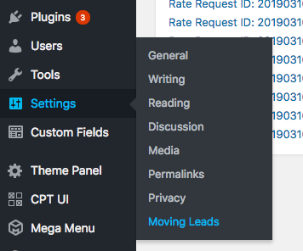

Here on this page you will see the items you can update. Be sure to click “Update” once you’re done editing. This page also has all of the fields to allow you to adjust your domestic pricing rates, which will be explained in detail later in the guide.

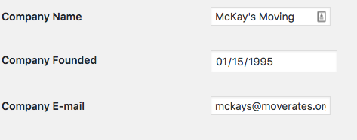

**Adding and Editing staff members**

To add a new staff member, begin on the admin dashboard and select Team Members from the left hand side menu and “Add New”.

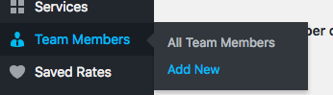

From here, add the team members name in the title field, and the biography in the text area below. You can also update their photo in the ‘featured image’ field on the right hand side. For best results, the pictures should be 250x250 pixels.

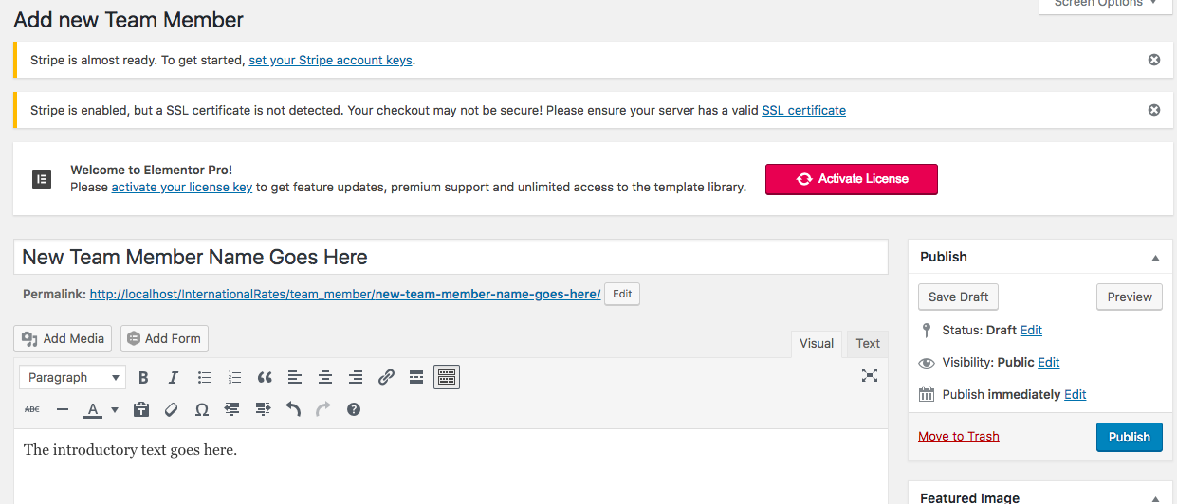

**Rates Engine – How it Works**

*International Rates Engine*

The international rates engine works by using the following inputs from the user.

* Origin City, Country
* Destination City, Country
* Volume (CBM)
* Mode (Road 20, Road 40, Air, LCL, 20 FCL, 40 FCL, 40 High)
* Accessories
  + Carton Drop
  + Picture hanging
  + Long Carry
  + Stair Carry
  + Holiday
  + Grand Piano
  + Upright Piano
  + No packing
  + No Unpacking

The detailed calculations are here below:

* **((Total volume * 35.314) * 6.5 lbs) = Total Shipment Volumetric Weight**
  + **If Air shipment, 10.41 lbs will be used.**
* **CWT weight = Total Shipment Volumetric Weight / 100**

The engine will then calculate the origin rates based on the Origin Service city by:

* Locate the appropriate mode rates (Air, LCL, 20 fcl, ect…)
* Calculates the charge for actual weight based on actual CWT
* Calculates the charge for weight break rate for the next bracket up from the actual weight bracket
* Calculates the minimum charge for the shipment mode
* The rates engine will then select the appropriate charge
  + If actual is above minimum and below weight break = actual
  + Actual below minimum = minimum
  + If actual above minimum, but below weight break = weight break

The rates engine is dynamic and also takes into account if weight breaks are below actuals and minimums, and will always select the appropriate weight.

Freight rate charges are produced by the rate engine by the same process above, but pulling from the Freight Rates fields on the origin city card for each each mode based on the destination city.

**Adding Service Locations & Rates**

Adding a new service location and rates is very easy with the MoveRates Interface. Please follow the steps here below.

1. Navigate to the admin screen
2. In the left hand menu, hover over “Cities & Rates” -> then click “Add New”.

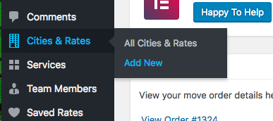

1. Enter the city and name in the title field in the format of “City, Country”.

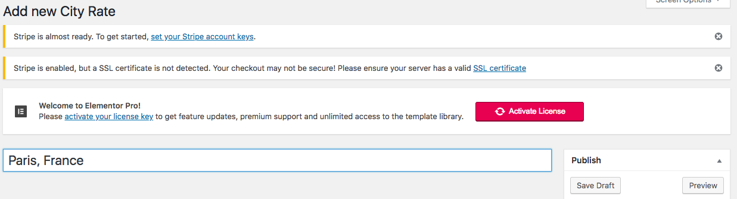

1. Fill in the Main field for the primary agent you will use for this city. The GPS latitude and GPS longitude fields are **not** needed, you can skip these.

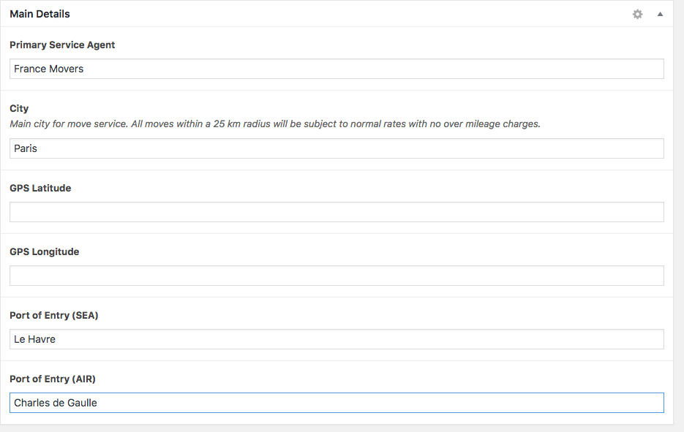

1. Scroll to “Air Rates” and Click “Add Rates”
2. Select “Origin”, enter in the agent’s origin rates for each weight bracket.
3. The rates should be based on a per 100 lbs (CWT) basis, per the label for each bracket.
4. Keep in mind, **minimum & weight breaks apply**. **All should be in USD.**
5. Click “Add Rates”, select “Destination”, enter the agent’s destination rates.
6. Each mode (Air, LCL, 20 FCL, ect..) should have **two rows** of rates, one for origin rates and one for destination rates.
7. Repeat for LCL, 20 FCL, 40 FCL.

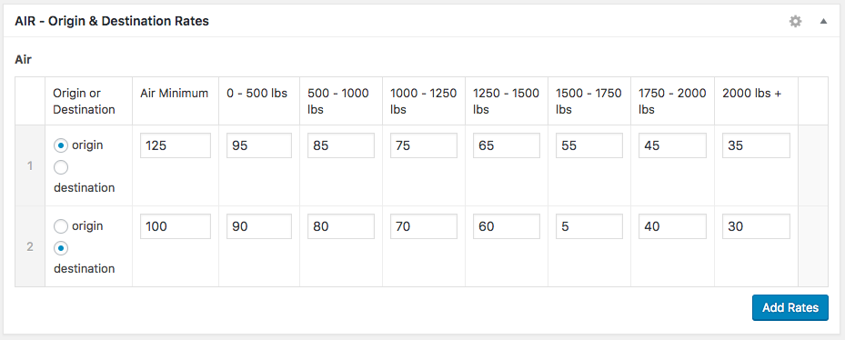

1. Scroll to the Freight Section
2. Add the **Outbound Freight** cost from this city to all of your service cities.
3. Each single row should be designated to a single destination country.
4. For example, if you have service locations of New York, Denver, and LA, then you need to enter freight rates from Paris to New York, to Denver, and to LA, so you will have a total of 3 completed rows.
5. An example is here below: 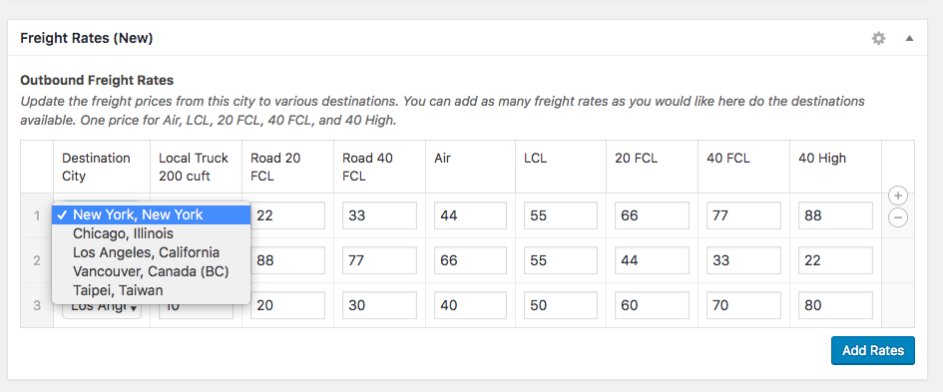
6. Click on “Update” in the top right corner of the screen to save.

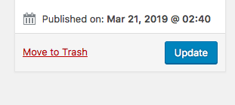

After you have updated this cities rates, you will need to add freight from you other locations to this new city. You can do this with the following steps:

1. Navigate to the “Custom Fields” in the left-hand side menu.

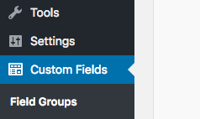

2. Click “Edit” for the “Freight Rates (New)” group

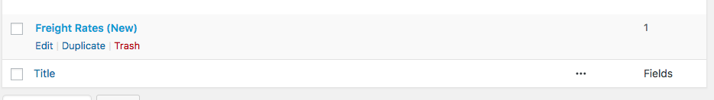

3. Click on “Outbound Freight Rates”, then on “Destination City” below.

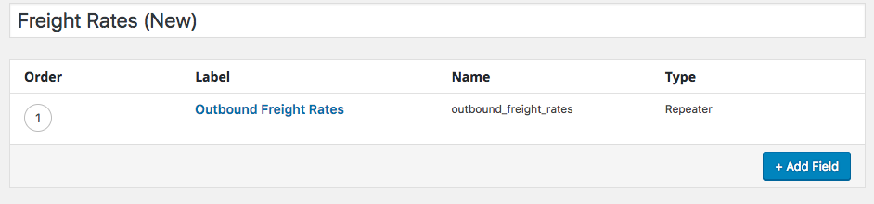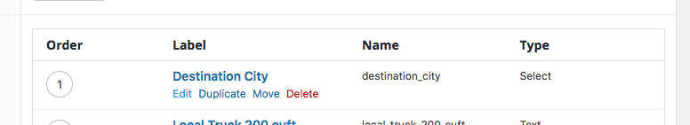

4. Scroll down to the “Choices section”, and add your new city here.

5. Immediately after, add the new city in the “values” section directly below. **Please follow the format of the example cities exactly, or the new city will not work in the rates engine.**

**Spaces = underscores, no commas, all lowercase**

|  |  |
| --- | --- |
| **Choice** | **Value** |
| Seattle, Washington | seattle_washington |
| ChangChun, China | changchun_china |
| Buenos Aires, Brazil | Buenos_aires_brazil |

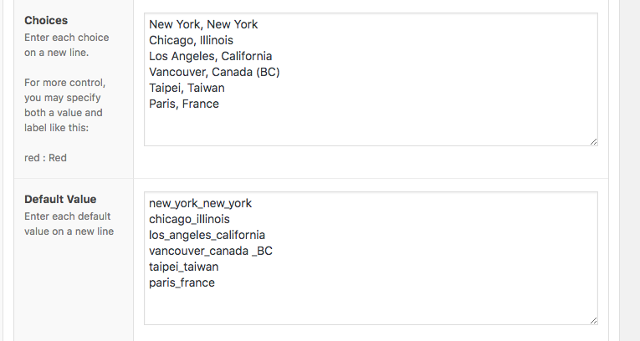

6. Click Update in the top right hand corner to save.

7. Once you have added this field, simply navigate back to “Cities & Rates” in the left-hand side column.

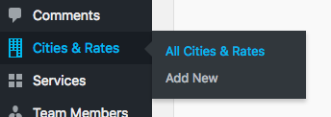

8. For each city, click in and add freight rates for the new location with the above sections instructions.

**Adding Domestic Rates**

Domestic rates are considered for any same-city / local moves. These are the rates that will be used in the ‘Domestic Moves’ Rate engine and portal.

1. Begin by navigating to the admin screen. Hover over the “settings” link in the left hand menu and click the ”Moving Leads” option.

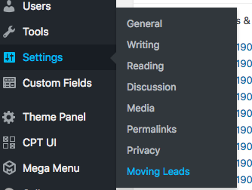

1. Scroll down until you see the “Domestic Pricing Table” options and begin to enter your rates.
2. Click “save Changes” at the bottom and your rates will be automatically updated.

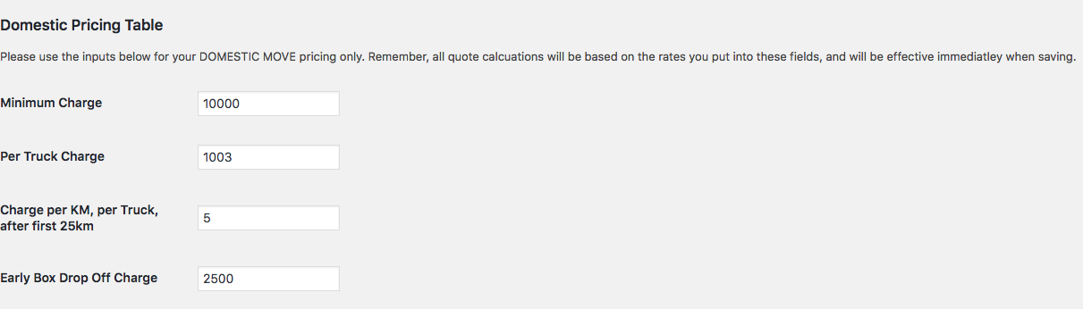

**Editing and Inventory – International Moves**

For moving customers (no moving company employee’s), simply:

* Navigate to your customer dashboard
  + ([www.youwebsite.com/customer-dashboard/](http://www.youwebsite.com/customer-dashboard/))
* Locate the Saved Rate or Booked Move you want to update
* Click ‘Edit inventory’
* Enter in new quantities for each item and click “Update”

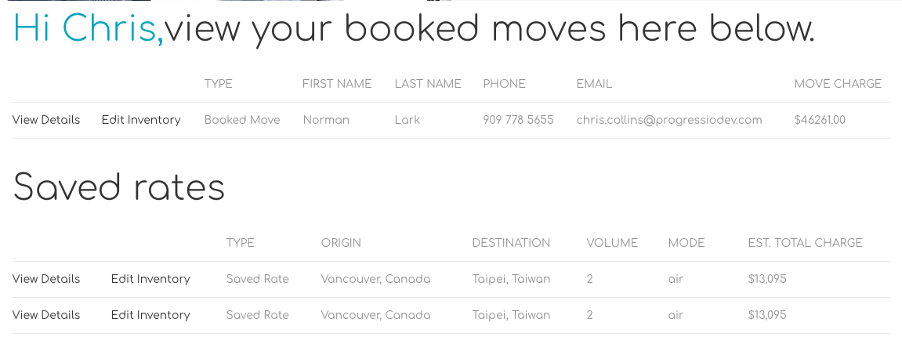

For moving company employee’s:

1. Navigate to the admin dashboard
2. Select either “Saved Rates” or “Woocommerce -> Orders”
3. Find the rate reference number you wish to edit and click the link
4. Scroll down and adjust the quantity field for each item you want to update
5. Scroll the top and click “Update” button in the top right hand corner.

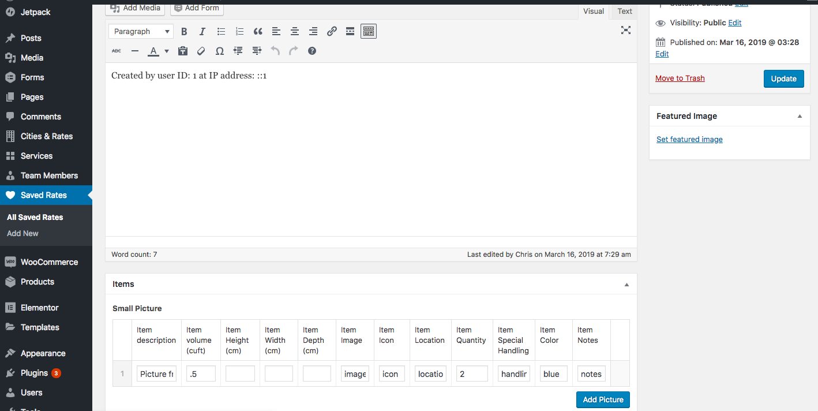

**Technical Appendix**

1. Shortcodes
   1. Edit-inventory
   2. Saved-rates

|  |  |  |
| --- | --- | --- |
| Shortcode | Page | Description |
|  |  |  |
| [saved-rates] | /saved-rate | Display all information for a single saved rates (i.e. is a single saved rates content template). |
| [address] |  |  |
| [email] |  |  |
| [phone] |  |  |
| [url] |  |  |
| [home-form] | /domestic-moving | Home address/elevator input form |
| [move-details-bar] | /domestic-moving | Volume, cuft, addresses summary bar |
| [home-maps-inventory-section] | /domestic-moving | Shows the inventory and map sectional for domestic moving calculator |
| [customer-dashboard] | /customer-dashboard | Show dashboard highlighting booked moves and saved rates for logged in user |
| [inventory-modal] | / | Inventory modal pop-up to enter in international inventory items |
| [edit-inventory] | /edit-inventory | Single view template allowing to edit an international inventory. |
| [inventory-repeater] | /edit-inventory | This will load within the [edit-inventory] shortcode to print the table and pre-populate with values. |
| [input-form] | / | Displays international rates input form bar |
| [route-map] | / | Displays international routing maps |
| [results-table] | / | Displays international rates results table |
| [single-order] | /move-details/ | Template to displays details of a single order |